Session 4

Strategy has 5 rules, more rules will indicate a cleaner higher winrate trade

HRN: the best pattern

In uptrend 2 bearish candles followed by a bullish

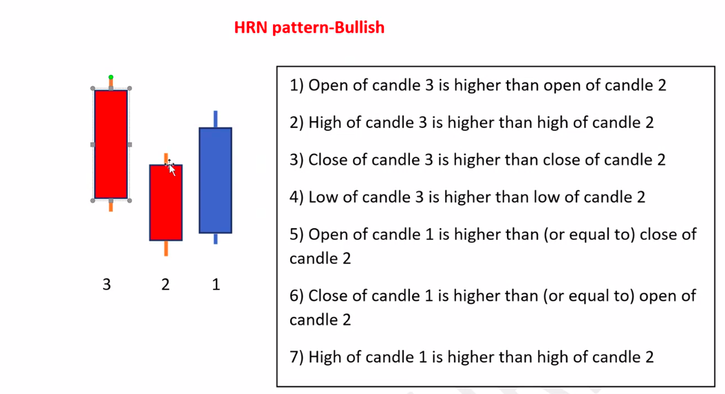

OHLC of 3 > OHLC of 2

O1 >= C2

C1 >= O2

H1 > H2

In downtrend 2 bullish candles followed by a bearish

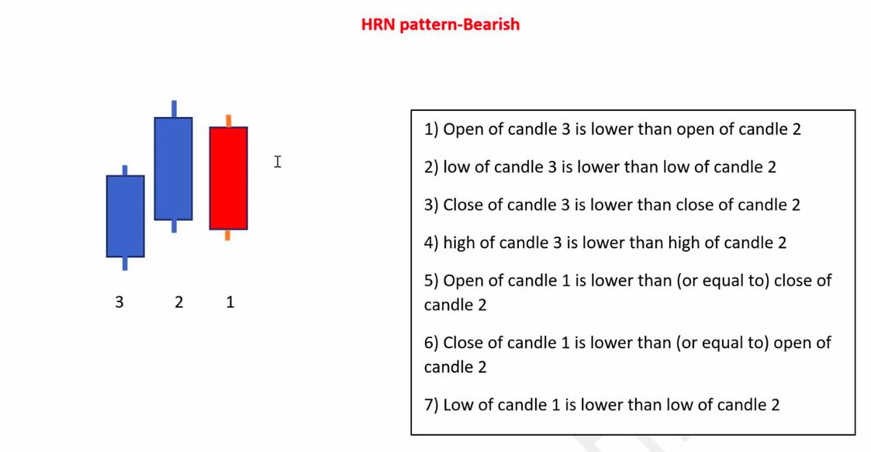

OHLC of 3 < OHLC of 2

O1 <= C2

C1 <= O2

L1 < L2

**Another Important Rule:**

1. while PB on 8 and 20, while spotting a pattern(HRN & Engulfing) before entry check if the MAs are increasing/decreasing in value in the transition of one candle to another , And while PB on 50, the rule applies to 50 and 20 only

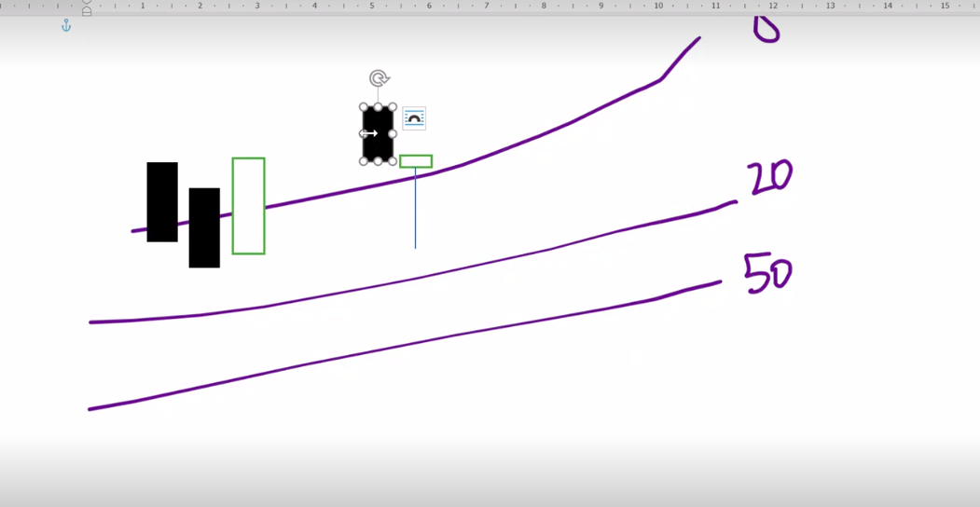

1. While Spotting Hammer, there should be one counterpart candle before it. While also increasing/decreasing just as mentioned in the point above

Make note that, in general the strategy focuses on registering a healthy PB after a Healthy movement, Strong Up and Strong Down. Strong Buyers and Strong Sellers